DEPLOYMENT TYPES

WHATS IS DEPLOYMENT?
The term Deployments refers the installation of a Web-Application on Web Application server.

WEB APPLICATION: webapp servers (Tomcat, Nginx, Jboss, ISS)
A web application is a program that can be accessed via a browser and is linked to a database.
Can interact with end users.
We can Read and Manipulate.
Complex Functionality.

WEBSITE: webserver: (Httpd, Nginx)
A website is a collection of related pages containing images, audio, or videos linked by a single domain name.
Can’t interact with end users.
We can’t Read and Manipulate.
Simple Functionality.

WHY WE NEED ?
The Main essence of the Deployments is
Adding New Feature s to the Application.
Removing the Bugs.
Enhancing the New Features.
Improving the Performance.
Breaking Large Applications to MicroServices.

THINGS NEED FOR THE DEPLOYMENT ?
We need to have Infra Setup.
New Release of code.
Involvement of Dev, QA and DevOps Team.
Creating New Db’s If needed.
Approval from RM (in case of New release).

THINSG TO CONSIDER AND TAKEN CARE WHILE DEPLOYMENT.
Need to take Backups of the Current Builds and DataBases.
Need To Provide Isolated Environments for Dev, Test and Prod.
Can be able to do RollBack if the Deployment fails in some cases.
Make sure we are deploying the correct env and Client Application Servers.

TYPES:
BLUE-GREEN DEPLOYMENT
ROLLING STRATEGIES
CANARY DEPLOYMENT
RECREATE STATEGY
A/B DEPLOYMENT

BLUE-GREEN DEPLOYMENT:
If we have some existing servers then we create new servers and we will route traffic by using ELB from existing servers to the new servers.
If it will not work properly we need to do Rollback
Blue is the Old code and the Green is New code.
Blue/Green Deployment: Version B is released alongside Version A, and then the traffic is switched over to Version B.
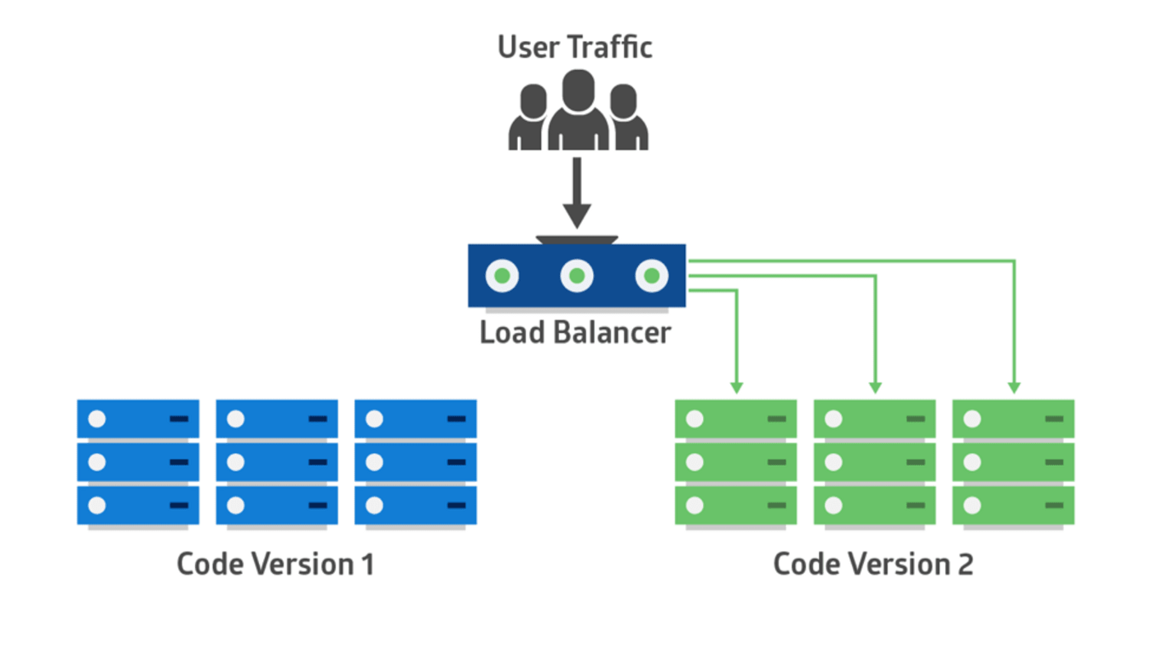
ROLLING STRATEGIES:
If you have some application servers running then you will create some new servers you will remove old.
in that case your old code and new code will be capable of running at same time in parallel environment that is old environment and new environment.
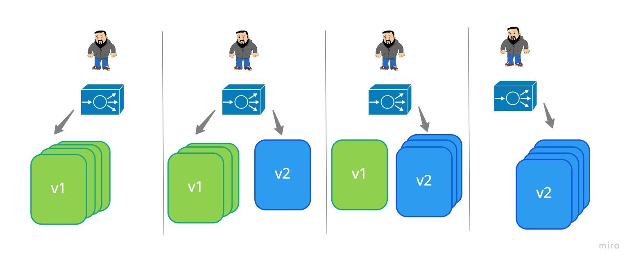

CANARY DEPLOYMENT:
It will keep updating new servers and will delete the old servers.
It is useful when two different codes need to be run in the new environment
Canary: Version B is released to a subgroup of users, then proceeds to a full rollout
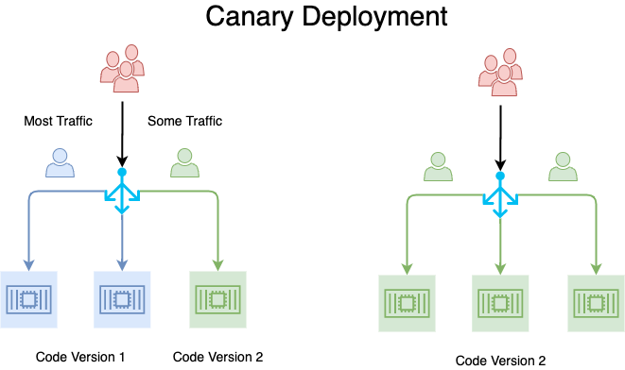
RECREATE STATEGY:
We need to Down all the servers and we need to deploy new version then we need to bring the services into Running state.
We can also achieve this on another way we need to create a separate infrastructure.
And you can migrate to new infra to minimise the downtime.
But in this case we can run previous, current and new code run in same time.
Here we required some downtime.
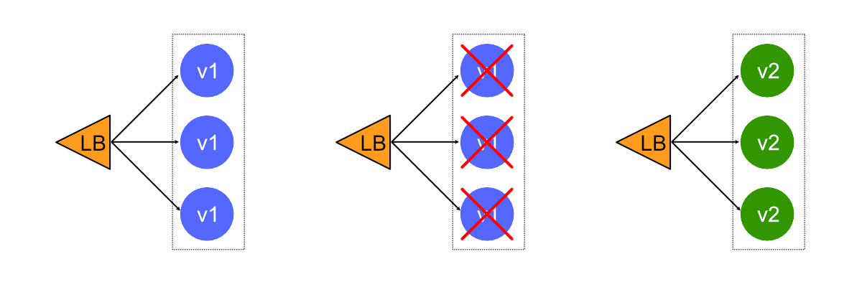

Recreate: Version A is terminated, and Version B is then deployed.

A/B DEPLOYMENT:
This will work on LoadBalancer.
If Port-A has old code and serving for server-1 the Port-B will server for the new code.
A/B Testing: Version B is released to a particular subset of users under specific conditions.
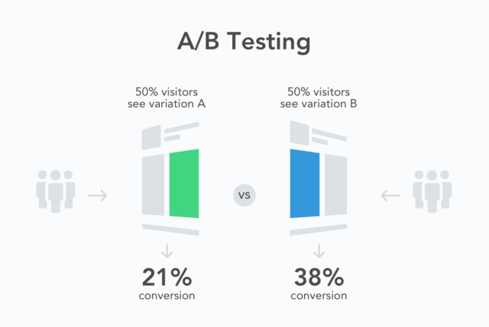
CUSTOM STATEGY:

Zero downtime
is a deployment method where your website or application is never down or in an unstable state during the deployment process. To achieve this the web server doesn't start serving the changed code until the entire deployment process is complete.

DAILY ACTIVITES:
1. checking the mails (24/7)
2. check servers load
3. Build & Deploy the apps through the pipelines
4. check the pending tickets
5. check the infra
6. create new documentations (confluence)
7. creating infra (one time activity)
8. we make builds & deployment jenkins
9. collaborations (teams)
10. attending standup calls
11. troubleshoot

MONOLITHIC PROJECT:
Q: TELL ME ABOUT YOUR CURRENT PROJECT YOU ARE WORKING ON ?
INTRO: THANKS FOR GIVING THE OPPURTUNITY TO EXPLAIN MY PROJECT.

1. IN MY COMPANY WE USE MONOLITHIC ARCHITECTURE FOR OUR PROJECT.
2. OUR REAL TIME WORK AS A DEVOPS ENGINEER WILL START WITH CREATING INFRA.
3. FOR INFRA CREATION WE USE TERRAFORM IN OUR COMPANY.
4. WE USE MODULES TO CREATE 3 TIER ARCHITECTURE IN AWS CLOUD.

5. ONCE INFRA GOT CREATED WE CONFIGURE THE SERVERS USING ANSIBLE.
6. WE INSTALL SOFTWARES ON WEB, APP, DB SERVERS BY USING PLAYBOOKS
7. WE CREATE ROLES AND WE EXECUTE THEM WHENEVER WE WANT.

8. OUR DEV WILL PUSH THE CODE TO GITHUB WE INTEGRATE CODE FROM GITHUB TO JENKINS
9. IN JENKINS WE DO CI (BUILD + TEST) AS RESULT WE GET ARTIFACT(WAR)
10. WE STORE ARTIFACTS ON S3 BUCKETS FOR ROLLBACK PURPOSE.
11. WE RUN THE PIPELINE THAT WILL DEPLOY THE APP AUTOMATICALLY TO THE DEV SERVERS.
12. AFTER DEV WE DEPLOY ON TEST AND UAT IF EVERY THING IS FINE WE DEPLOY THE APP TO PROD.

PIPELINE FLOW:
CODE -- > BUILD -- > TEST -- > SONARQUBE -- > ARTIFACT -- > S3 -- > DEPLOY -- > SLACK

13. AFTER DEPLOYING THE APP WE VERIFY THE APP IS RUUNING OR NOT FROM ELB DNS.
14. FINALLY ONCE EVERYTHING IS DONE WE MONITOR THE SERVERS FROM GRAFANA.

TOOLS:
CLOUD : AWS
INFRA : TERRAFORM
CODE : GIT & GITHUB
CI : JENKINS
CONFIG MANAGEMENT: ANSIBLE
MONITORING : PROMETHEUS & GARFANA
APP SERVER : TOMCAT
NOTIFICATIN : SLACK
CODE QUALITY : SONARQUBE

ISSUES YOU FACED IN THE PROJECT:

SIR IN OUR PROJECT ONE OF THE MOST COMMON THING I FACED IS PIPELINE FAILURES, BUT HOW I RESLOVED IS

1. PIPELINE FAILURES: DEVOPS TEAM
WE NEED TO CHECK LOGS
WE NEED TO CHECK CONFIGURATION
WE NEED TO CHECK CREDS
WE NEED TO CHECK PLUGINS
WE NEED TO CHECK DEPENDENCIES

2. INFRA FAILURES: DEVOPS TEAM
WE NEED TO CHECK THE PLUGINS
WE NEED TO THE CONFIG AND SYNTAX ISSUES
WE NEED TO CHECK THE PROVIOSINERS
MODULE STRUCTURE

3. CODE FAILURES: DEV TEAM
WE NEED TO CHECK SONARQUBE DASHBOARD
WE NEED TO CHECK COMPILE STAGE
WE NEED TO SEND LOGS TO DEV

IF YOUR PROD APP IS NOT WORKING PROPERLY WHAT YOU GONNA DO : ROLLBACK
IF YOUR PROD APP IS WORKING SLOWLY WHAT YOU GONNA DO : SCALING, EDGE LOC
IF YOUR PROD APP IS NOT SHOWING APP TO USER : CHECK THE SERVICE HTTPD/TOMCAT

MICROSERVICE PROJECT:
Q: TELL ME ABOUT YOUR CURRENT PROJECT YOU ARE WORKING ON ?
INTRO: THANKS FOR GIVING THE OPPURTUNITY TO EXPLAIN MY PROJECT.

1. IN MY COMPANY WE USE MICROSERVICE ARCHITECTURE FOR OUR PROJECT.
2. OUR REAL TIME WORK AS A DEVOPS ENGINEER WILL START WITH CREATING CLUSTER.
3. FOR INFRA CREATION WE USE TERRAFORM/EKS/KOPS IN OUR COMPANY.
4. WE USE MODULES TO CREATE 3 TIER ARCHITECTURE IN AWS CLOUD.

5. ONCE CLUSTER GOT CREATED WE CONFIGURE THE CLUSTER.
6. WE INSTALL CNI, INGRESS, METRIC SERVER, OIDC, Helm -----
7. WE TEST CLUSTER IS WORKING OR NOT BY CREATION SOME DEMO PODS.

8. OUR DEV WILL PUSH THE CODE TO GITHUB WE INTEGRATE CODE FROM GITHUB TO JENKINS.
9. IN JENKINS WE DO CI (BUILD + TEST) AS RESULT WE GET IMAGE
10. WE STORE IMAGE DOCKER HUB.
11. WE RUN THE PIPELINE/ARGOCD THAT WILL DEPLOY THE APP AUTOMATICALLY TO THE CLUSTER.
12. AFTER DEV NS WE DEPLOY ON TEST AND UAT IF EVERY THING IS FINE WE DEPLOY THE APP TO PROD.

PIPELINE FLOW:
CODE -- > BUILD -- > TEST -- > SONARQUBE -- > GATEQUALITY -- > OWASP -- > TRIVY -- > BUILD -- > TAG & PUSH TO DOCKERHUB -- > SLACK NOITFY
GITHUB (MANIFEST) -- > ARGOCD -- > DEPLOY TO CLUSTER

13. AFTER DEPLOYING THE APP WE VERIFY THE APP IS RUUNING OR NOT FROM ELB DNS.
14. FINALLY ONCE EVERYTHING IS DONE WE MONITOR THE SERVERS FROM GRAFANA.

TOOLS:
CLOUD : AWS
INFRA : TERRAFORM/EKS/KOPS
CODE : GIT & GITHUB
CI : JENKINS
CD : ARGOCD
PACKAGE MANAGER : HELM
MONITORING : PROMETHEUS & GARFANA
APP SERVER : TOMCAT
NOTIFICATIN : SLACK
CODE QUALITY : SONARQUBE
IMAGE SCAN : TRIVY

TERRAFORM:
STATEFILE, MODULES, WORKSPACE, PROVIDER & PROVISONERS, META-ARGS, VARIABLES, DEBUG, HCP
K8S:
DEPLOYMENT, NAMESPACE, ARCHITERUTRE, QUOTAS, MULTI-NODE CLUSTER, RBAC, CM & SECRETS, ENV, HELM, STATIC PODS & DAMEONSETS, SVCS, EKS, HPA & VPA, KUSTOMIZE, PV,PVC, SC, SCHEDULING, SS
DOCKER:
DOCKER BASICS, DOCKERFILE, DOCKER SWARM
JENKINS:
PIPELINES, MASTER & SLAVE, POST ACTIONS, CICD, PLUGINS, SYNTAX, SCHEULING.
ANSIBLE:
ROLES, PLAYBOOKS, VAULT, CONDITIONS, HANDLERS & LOOPS, MODULES

